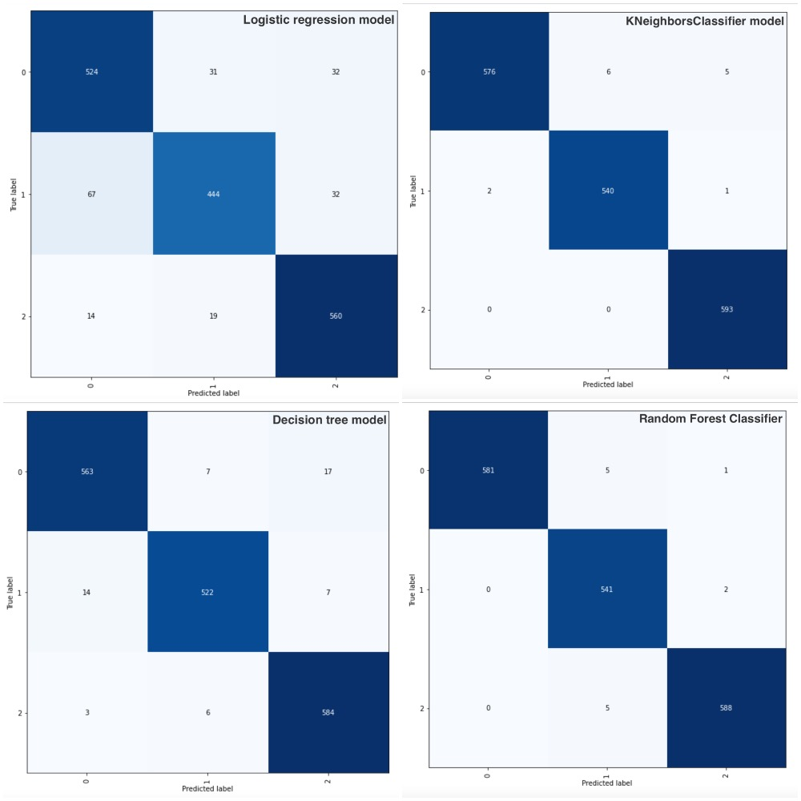

The True-Positive, True-Negative, False-Positive, False-Negative values for all three activities (**Logistic Regression Model)** using the manual calculations (Mohajon, 2020):

**Walking Activity (0)**

True-Positive: cell 1 (**524**)

True-Negative: cell 5 (444) + cell 6 (32) + cel1 8 (19) + cell 9 (560) =**1055**

False-Positive: cell 2 (31) + cell 3 (19) = **50**

False-Negative: cell 4 (67) + cell 7 (14) = **81**

**Jumping Activity (1)**

True-Positive: cell 5 (**444**)

True-Negative: cell 1 (524) + cell 3(32) + cel1 7 (14) + cell 9 (560) =**1130**

False-Positive: cell 4 (67) + cell 6 (32) =**99**

False-Negative: cell 2 (31) + cell 8 (19) = **50**

**Drop & Pickup Activity (2)**

True-Positive: cell 9 (**560**)

True-Negative: cell 1 (524) +cell 2 (31) +cell 4 (67) +cell 5 (444) =**1066**

False-Positive: cell 7 (14) + cell 8 (19) = **33**

False-Negative: cell 3 (32) + cell 6 (32) = **64**

The True-Positive, True-Negative, False-Positive, False-Negative values for all three activities (**KNeighborsClassifier Model)** using the manual calculations (Mohajon, 2020):

**Walking Activity (0)**

True-Positive: cell 1 (**576**)

True-Negative: cell 5 (540) + cell 6 (1) + cel1 8 (0) + cell 9 (593) =**1134**

False-Positive: cell 2 (6) + cell 3 (5) = **11**

False-Negative: cell 4 (2) + cell 7 (0) = **2**

**Jumping Activity (1)**

True-Positive: cell 5 (**540**)

True-Negative: cell 1 (576) + cell 3(5) + cel1 7 (0) + cell 9 (593) =**1174**

False-Positive: cell 4 (2) + cell 6 (1) =**3**

False-Negative: cell 2 (6) + cell 8 (0) = **6**

**Drop & Pickup Activity (2)**

True-Positive: cell 9 (**593**)

True-Negative: cell 1 (576) +cell 2 (6) +cell 4 (2) +cell 5 (540) =**1124**

False-Positive: cell 7 (0) + cell 8 (0) = **0**

False-Negative: cell 3 (5) + cell 6 (2) = **7**

The True-Positive, True-Negative, False-Positive, False-Negative values for all three activities (**Decision Tree Model)** using the manual calculations(Mohajon, 2020):

**Walking Activity (0)**

True-Positive: cell 1 (**563**)

True-Negative: cell 5 (522) + cell 6 (7) + cel1 8 (6) + cell 9 (584) = **1119**

False-Positive: cell 2 (7) + cell 3 (17) = **24**

False-Negative: cell 4 (14) + cell 7 (3) = **17**

**Jumping Activity (1)**

True-Positive: cell 5 (**522**)

True-Negative: cell 1 (563) + cell 3(17) + cel1 7 (3) + cell 9 (584) =**1167**

False-Positive: cell 4 (14) + cell 6 (7) =**21**

False-Negative: cell 2 (7) + cell 8 (6) = **13**

**Drop & Pickup Activity (2)**

True-Positive: cell 9 (**584**)

True-Negative: cell 1 (563) +cell 2 (7) +cell 4 (14) +cell 5 (522) =**1106**

False-Positive: cell 7 (3) + cell 8 (6) = **9**

False-Negative: cell 3 (17) + cell 6 (7) = **24**

The True-Positive, True-Negative, False-Positive, False-Negative values for all three activities (**Random Forest Classifier)** using the manual calculations (Mohajon, 2020):

**Walking Activity (0)**

True-Positive: cell 1 (**581**)

True-Negative: cell 5 (541) + cell 6 (2) + cel1 8 (5) + cell 9 (588) = **1136**

False-Positive: cell 2 (5) + cell 3 (1) = **6**

False-Negative: cell 4 (0) + cell 7 (0) = **0**

**Jumping Activity (1)**

True-Positive: cell 5 (**541**)

True-Negative: cell 1 (581) + cell 3(1) + cel1 7 (0) + cell 9 (588) =**1170**

False-Positive: cell 4 (0) + cell 6 (2) =**2**

False-Negative: cell 2 (5) + cell 8 (5) = **10**

**Drop & Pickup Activity (2)**

True-Positive: cell 9 (**588**)

True-Negative: cell 1 (581) +cell 2 (5) +cell 4 (0) +cell 5 (541) =**1127**

False-Positive: cell 7 (0) + cell 8 (5) = **5**

False-Negative: cell 3 (1) + cell 6 (2) = **3**